**System Prototypes and Models**

**Prototype - System Architecture:** The diagram below demonstrates the interactions between Karoline, the system, and the customer. PMS = Payment Management System, DBMS = Database Management System.

.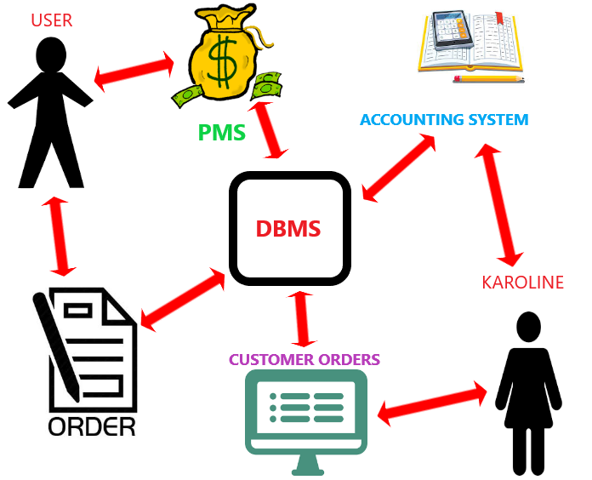

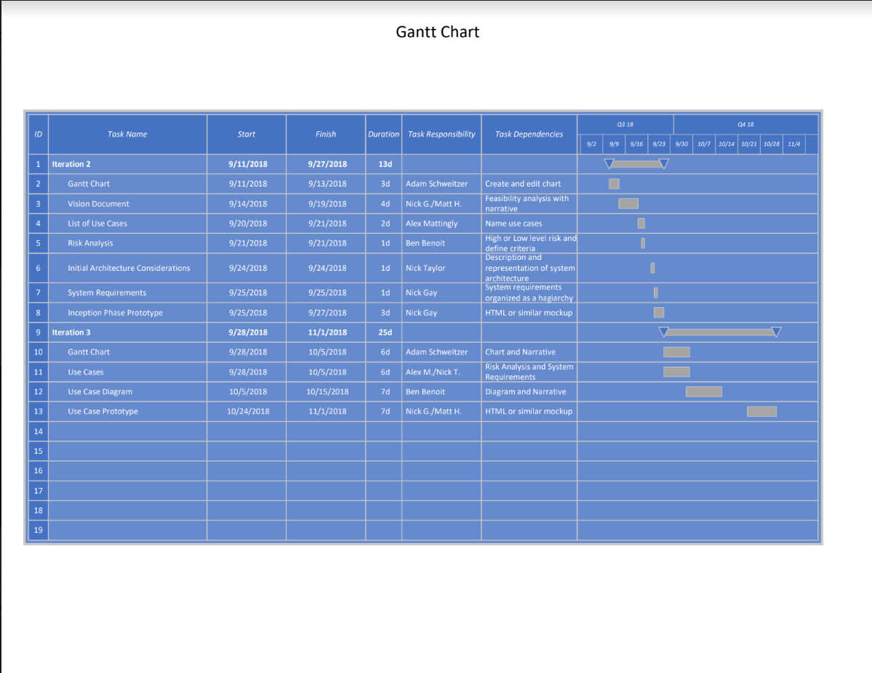

**Model - Gantt Chart:** In the Gantt chart, horizontal bars are drawn to represent the duration of each task, and as people work on tasks, the appropriate bars are filled in proportionately to how much of the task is finished.

**Prototype - Homepage:** The following image was created to give Sweet Karoline’s an idea of what the homepage of the website may look like. It includes tabs for the home page, order form, the menu, a gallery for photos of products, an about page, and the contact page. 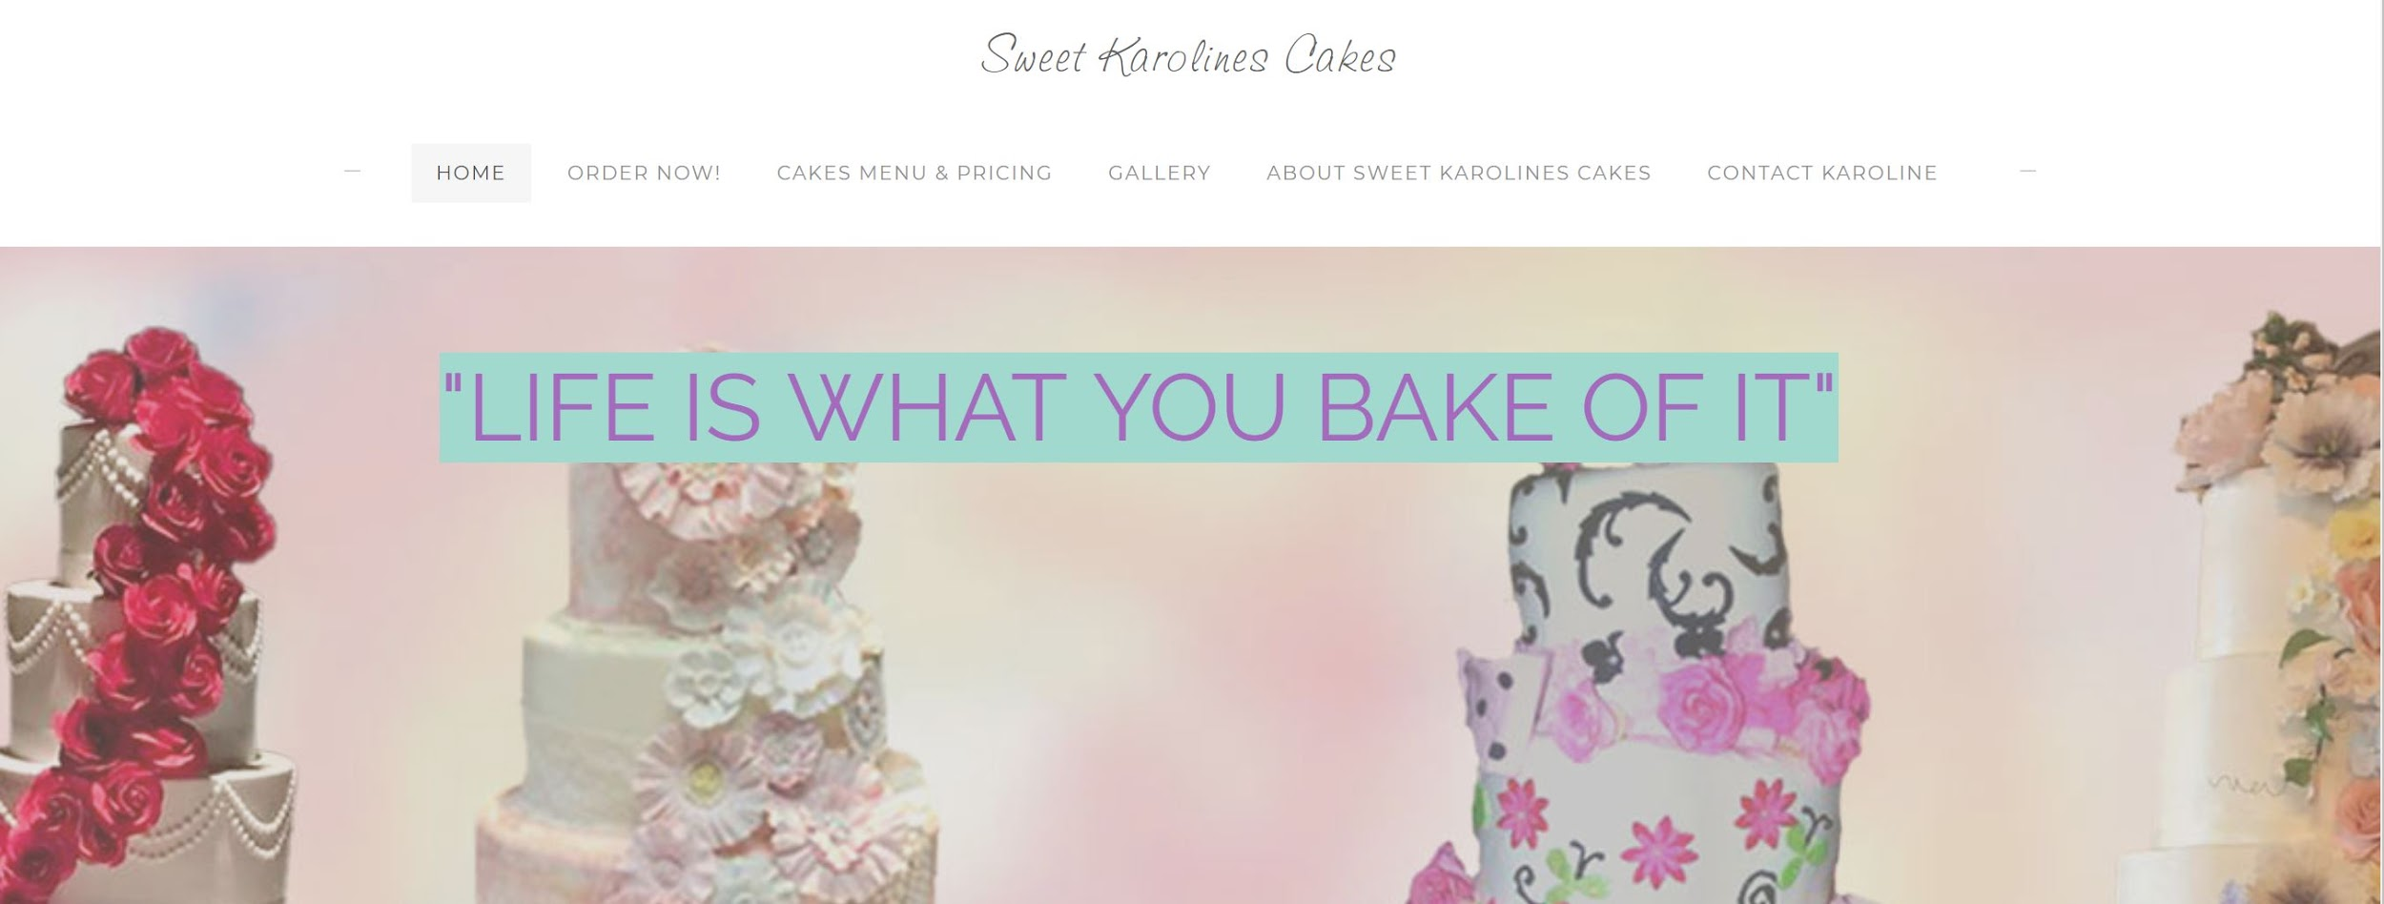

**Prototype - Order Form:** This is a basic prototype of what the order form will look like when the website is completed. It contains many fields that need to be filled with customer information. There is also a text box for any additional information, a calendar that lists available order dates, and the form gives the customer an option to upload a photo to give Karoline a better idea of what they want. Despite aesthetics, however, the main purpose of this form is to allow the customer to make an order, and it is designed in a way to make this an easy process.

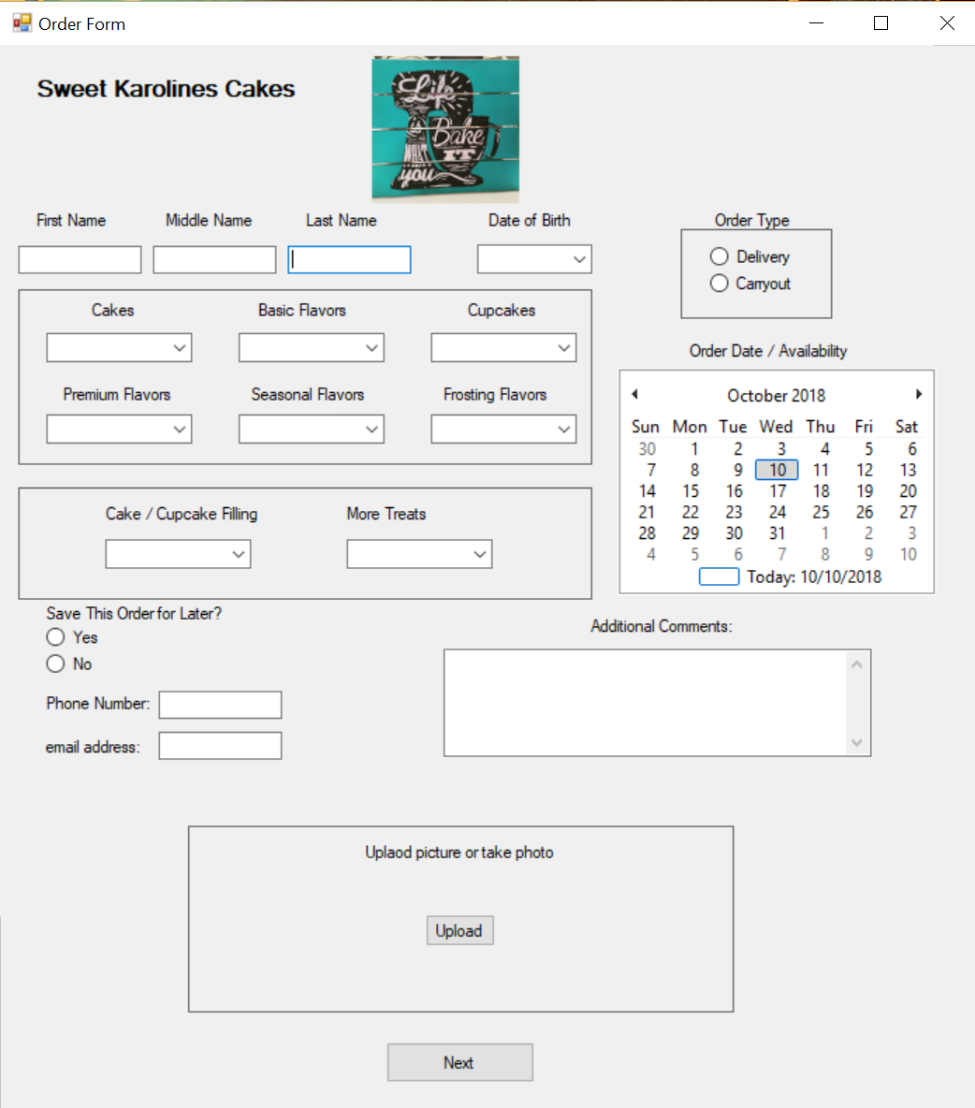

**Prototype - Payment Form:** This is a basic prototype of what the payment form will look like when the website is completed. Paypal will be the sole method of payment that is accepted, so it is displayed at the top of the form. The symbols for the various credit card companies signify that they are all processed through paypal. Since it can be a liability, Sweet Karoline’s website will not handle credit card information directly. The rest of the form consists of an order summary that displays the type of product that was ordered and the total cost. 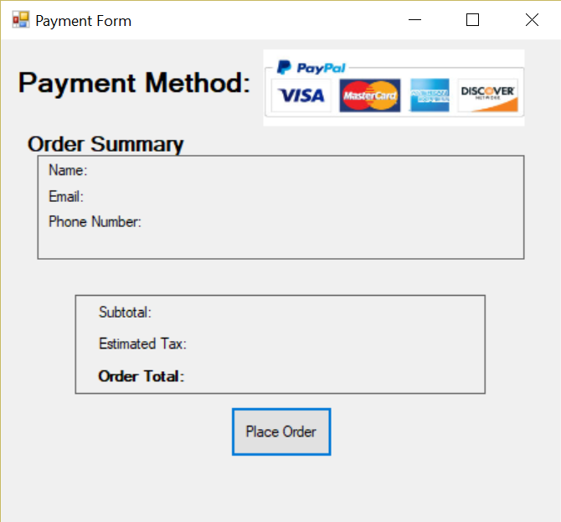

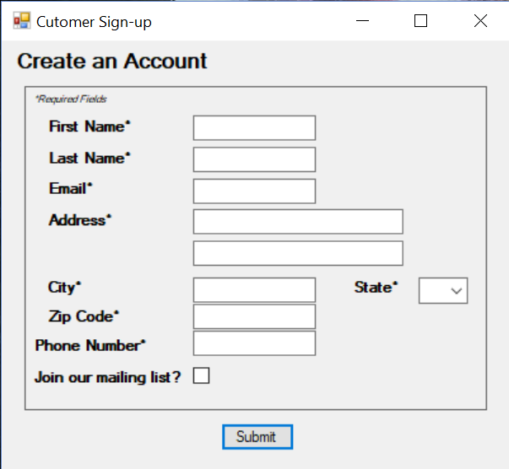

**Prototype - Account Setup:** This is a basic prototype of what the account creation form will look like when the website is completed. Nearly all of the fields require the customer to enter their information to create an account with Sweet Karoline’s Cakes. The form also includes an option to join a mailing list.

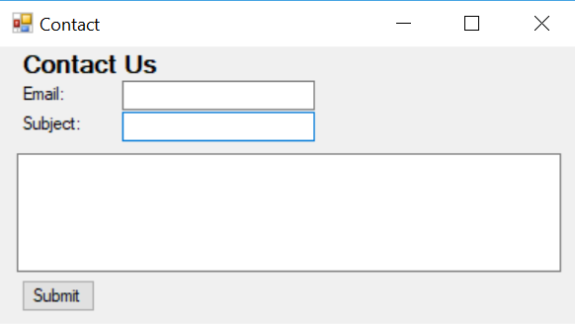

**Prototype - Contact Form:** This is a basic prototype of what the contact form will look like when the website is completed. The customer will enter their email, add a subject, and compose their message. The contact form will forward all messages to the administrative email.